Milestone 6
John McIntyre
CST-452
7/19/2026
Implementation Plan:
User Story / Use Case | Development Task | Estimated Hours | Actual Hours | Percent Complete
As a new user, I want to create an account so that I can log into the application. | Create registration form and database insert functionality | 2 | 3 | 100%
As a returning user, I want to log into my account so that I can access my personal workout data. | Create login validation and session handling | 2 | 3 | 100%
As a user, I want to log my workouts so that I can keep track of what I did at the gym. | Build workout entry form and database integration | 3 | 4 | 100%
As a user, I want to view my past workouts so that I can see my training history. | Create DataGridView workout history screen | 3 | 3 | 100%
As a user, I want to edit a workout I already logged so that I can fix any mistakes. | Create workout editing functionality | 2 | 3 | 100%
As a user, I want to delete a workout so that I can remove entries I no longer need. | Add workout deletion functionality | 1 | 1 | 100%
As a user, I want the app to connect to a database so that my data is saved between sessions. | Configure MySQL connectivity and queries | 4 | 5 | 100%
As a user, I want the app to have a clean layout so that it is easy to navigate. | Apply modern styling and dashboard layout | 2 | 2 | 100%
As a developer, I want to test all features so that I can confirm everything works as expected. | Perform system testing | 3 | 3 | 100%
As a user, I want to see my progress over time so that I can tell if I am getting stronger. | Create progress statistics screen | 2 | 2 | 100%
As a user, I want my password to be stored securely so that my account is protected. | Implement password hashing on registration and login | 2 | 0 | 0%
As a user, I want to log out of my account so that I can keep my data secure. | Add logout button to dashboard and clear user session | 1 | 1 | 100%
As a user, I want to confirm before deleting a workout so that I do not accidentally remove my data. | Add confirmation dialog before deleting a workout | 1 | 1 | 100%
As a user, I want the app to have a modern and clean interface so that it is easy and enjoyable to use. | Redesign dashboard layout with consistent colors, fonts, and button styling | 2 | 2 | 100%
As a user, I want to filter my workout history by date so that I can find specific workouts quickly. | Add date filter to workout history screen | 2 | 2 | 100%
As a user, I want to see my workout progress on a graph so that I can visually track my improvement over time. | Create a new chart form with a line graph showing weight lifted over time | 3 | 3 | 100%
As a user, I want to see motivational messages on the dashboard so that I stay encouraged to keep working out. | Add motivational notification label to dashboard that displays encouraging messages on login | 1 | 1 | 100%

Percent of User Stories Complete for this Iteration: 100%
Percent of User Stories Complete for Entire Project:93%

Functional Requirements Traceability Mapping:
Project Name: McIntyre Fitness App | Project Description: A Windows Forms workout tracking application built in C# and MySQL
ID | Assoc ID | Functional Requirement / Use Case | Architectural/Design Document | Software Module(s) | Test Case Number
001 | 1.1 | Users can register accounts | Section 2 - User Object | RegisterForm.cs – btnRegister_Click | TC-001
002 | 1.2 | Users can log in | Section 6 - Detailed Specifications | LoginForm.cs – btnLogin_Click | TC-002
003 | 1.3 | Users can log workouts | Section 2 - Workout Object | WorkoutForm.cs – btnSaveWorkout_Click | TC-003
004 | 1.4 | Users can view workout history | Section 2 - Workout Object | WorkoutHistoryForm.cs – LoadWorkouts | TC-004
005 | 1.5 | Users can edit workouts | Section 2 - Workout Object | WorkoutEditForm.cs – btnSave_Click | TC-005
006 | 1.6 | Users can delete workouts | Section 2 - Workout Object | WorkoutHistoryForm.cs – btnDeleteWorkout_Click | TC-006
007 | 1.7 | Users can track progress | Section 5 - Algorithm Descriptions | ProgressForm.cs – ProgressForm_Load | TC-007
008 | 1.8 | Users can log out | Section 8 - System Security | DashboardForm.cs – btnLogout_Click | TC-008
009 | 1.9 | Users have to confirm before they delete | Section 8 – System Security | WorkoutHistoryForm.cs – btnDeleteWorkout_Click | TC-010
010 | 1.10 | Looks clean for user’s | Section 6 - Detailed Specifications | DashboardForm.cs – DashboardForm_Load | TC-011
011 | 1.11 | Users can filter workout history by date | Section 2 - Workout Object | WorkoutHistoryForm.cs – btnFilter_Click | TC-012
012 | 1.12 | Users can view workout progress as a line graph | Section 5 - Algorithm Descriptions | WorkoutChartForm.cs – WorkoutChartForm_Loa | TC-013
013 | 1.13 | Users see motivational messages on the dashboard | Section 6 - Detailed Specifications | DashboardForm.cs – DashboardForm_Load | TC-014

Source Code Listing:
File / Class | Description
LoginForm.cs | Handles user authentication
RegisterForm.cs | Registers new users
DashboardForm.cs | Main dashboard navigation
WorkoutForm.cs | Adds workouts
WorkoutHistoryForm.cs | Displays workout history
WorkoutEditForm.cs | Edits workout entries
ProgressForm.cs | Displays user statistics
DatabaseHelper.cs | Handles MySQL operations
UserSession.cs | Stores logged in user data

Test Plan and Test Cases:
Project Name: McIntyre Fitness App | Test Designed By: John McIntyre
Module Name: Registration | Test Designed Date: 6/18/2026
Release Version: 1.0 | Test Executed By: John McIntyre | Test Execution Date: 6/18/2026
Test Case# | Test Title | Test Steps | Test Data | Expected Result | Actual Result | Pass/Fail Status
TC-001 | Open Registration Form | Open registration form | N/A | Registration screen appears | Registration screen appeared | Pass
TC-001 | Enter Username | Enter username | testuser | Username accepted | Username accepted | Pass
TC-001 | Enter Password | Enter password | Password123 | Password accepted | Password accepted | Pass
TC-001 | Submit Registration | Click Register | N/A | User inserted into database and success message displayed | User inserted successfully | Pass
TC-001 | Duplicate Username | Enter existing username and click Register | testuser | Error message displayed | Error message displayed | Fail
TC-001 | Empty Fields | Leave username blank and click Register | N/A | Error or registration fails | Registration failed gracefully | Fail

Project Name: McIntyre Fitness App | Test Designed By: John McIntyre
Module Name: Login | Test Designed Date: 6/18/2026
Release Version: 1.0 | Test Executed By: John McIntyre | Test Execution Date: 6/18/2026
Test Case# | Test Title | Test Steps | Test Data | Expected Result | Actual Result | Pass/Fail Status
TC-002 | Open Login Form | Open login form | N/A | Login screen appears | Login screen appeared | Pass
TC-002 | Enter Username | Enter username | testuser | Username accepted | Username accepted | Pass
TC-002 | Enter Password | Enter password | Password123 | Password accepted | Password accepted | Pass
TC-002 | Submit Login | Click Login | N/A | Dashboard opens successfully | Dashboard opened | Pass
TC-002 | Wrong Password | Enter incorrect password and click Login | wrongpass | Invalid credentials message displayed | Error message displayed | Pass
TC-002 | Wrong Username | Enter nonexistent username and click Login | fakeuser | Invalid credentials message displayed | Error message displayed | Pass

Project Name: McIntyre Fitness App | Test Designed By: John McIntyre
Module Name: Create Workout | Test Designed Date: 6/18/2026
Release Version: 1.0 | Test Executed By: John McIntyre | Test Execution Date: 6/18/2026
Test Case# | Test Title | Test Steps | Test Data | Expected Result | Actual Result | Pass/Fail Status
TC-003 | Open Workout Form | Open workout form | N/A | Workout form appears | Workout form appeared | Pass
TC-003 | Enter Exercise | Enter exercise name | Bench Press | Exercise accepted | Exercise accepted | Pass
TC-003 | Enter Sets/Reps/Weight | Enter sets, reps, weight | 3 / 10 / 185 | Data accepted | Data accepted | Pass
TC-003 | Save Workout | Click Save Workout | N/A | Workout saved successfully | Workout saved | Pass
TC-003 | Empty Exercise Name | Leave exercise name blank and click Save | N/A | Error or save fails | Save failed gracefully | Pass

Project Name: McIntyre Fitness App | Test Designed By: John McIntyre
Module Name: View Workout History | Test Designed Date: 6/18/2026
Release Version: 1.0 | Test Executed By: John McIntyre | Test Execution Date: 6/18/2026
Test Case# | Test Title | Test Steps | Test Data | Expected Result | Actual Result | Pass/Fail Status
TC-004 | Open History Form | Open workout history form | N/A | History screen appears | History screen appeared | Pass
TC-004 | Load Workouts | Load workouts for logged in user | Existing workout records | DataGridView populates with workouts | Workouts loaded correctly | Pass
TC-004 | No Workouts | Load history with no workouts logged | No records | Empty DataGridView displayed | Empty grid displayed | Pass

Project Name: McIntyre Fitness App | Test Designed By: John McIntyre
Module Name: Edit Workout | Test Designed Date: 6/18/2026
Release Version: 1.0 | Test Executed By: John McIntyre | Test Execution Date: 6/18/2026
Test Case# | Test Title | Test Steps | Test Data | Expected Result | Actual Result | Pass/Fail Status
TC-005 | Open History | Open workout history | N/A | History displayed | History displayed | Pass
TC-005 | Select Workout | Select a workout from the list | Existing workout | Workout selected | Workout selected | Pass
TC-005 | Open Edit Form | Click Edit | N/A | Edit form appears | Edit form appeared | Pass
TC-005 | Modify Workout | Change weight value | Weight = 225 | Updated values accepted | Values updated | Pass
TC-005 | Save Changes | Click Save | N/A | Workout updates successfully | Workout updated | Pass
TC-005 | Edit Without Selection | Click Edit with no workout selected | N/A | Error message displayed | Error message displayed | Pass

Project Name: McIntyre Fitness App | Test Designed By: John McIntyre
Module Name: Delete Workout | Test Designed Date: 6/18/2026
Release Version: 1.0 | Test Executed By: John McIntyre | Test Execution Date: 6/18/2026
Test Case# | Test Title | Test Steps | Test Data | Expected Result | Actual Result | Pass/Fail Status
TC-006 | Open History | Open workout history | N/A | History displayed | History displayed | Pass
TC-006 | Select Workout | Select a workout | Existing workout | Workout selected | Workout selected | Pass
TC-006 | Delete Workout | Click Delete | N/A | Workout removed from database | Workout deleted | Pass
TC-006 | Refresh History | Refresh history after delete | N/A | Deleted workout no longer visible | Workout no longer visible | Pass
TC-006 | Delete Without Selection | Click Delete with no workout selected | N/A | Error message displayed | Error message displayed | Pass

Project Name: McIntyre Fitness App | Test Designed By: John McIntyre
Module Name: Progress Tracking | Test Designed Date: 6/18/2026
Release Version: 1.0 | Test Executed By: John McIntyre | Test Execution Date: 6/18/2026
Test Case# | Test Title | Test Steps | Test Data | Expected Result | Actual Result | Pass/Fail Status | Notes
TC-007 | Open Progress Form | Open progress screen | N/A | Progress screen appears | Progress screen appeared | Pass
TC-007 | View Total Workouts | Load progress stats | Existing workout records | Total workout count displayed correctly | Count displayed correctly | Pass
TC-007 | View Total Weight Lifted | Load progress stats | Existing workout records | Total weight lifted displayed correctly | Total weight displayed correctly | Pass
TC-007 | View Heaviest Lift | Load progress stats | Existing workout records | Heaviest lift displayed correctly | Max weight displayed correctly | Pass
TC-007 | View Favorite Exercise | Load progress stats | Existing workout records | Most logged exercise displayed | Favorite exercise displayed | Pass
TC-007 | No Workouts Logged | Open progress with no workout data | No records | Stats show zero or default values | Zeros displayed | Pass

Project Name: McIntyre Fitness App | Test Designed By: John McIntyre
Module Name: Logout | Test Designed Date: 6/18/2026
Release Version: 1.0 | Test Executed By: John McIntyre | Test Execution Date: 6/18/2026
Test Case# | Test Title | Test Steps | Test Data | Expected Result | Actual Result | Pass/Fail Status
TC-008 | Click Logout | Click the logout button on the dashboard | N/A | Session cleared and login form displayed | Login form displayed | Pass
TC-008 | Session Cleared | After logout attempt to navigate back | N/A | User cannot access dashboard without logging in again | Access denied | Pass

Project Name: McIntyre Fitness App | Test Designed By: John McIntyre
Module Name: Delete Confirmation | Test Designed Date: 6/18/2026
Release Version: 1.0 | Test Executed By: John McIntyre | Test Execution Date: 6/18/2026
Test Case# | Test Title | Test Steps | Test Data | Expected Result | Actual Result | Pass/Fail Status
TC-010 | Confirm Delete | Select a workout and click Delete | Existing workout | Confirmation dialog appears | Dialog appeared | Pass
TC-010 | Cancel Delete | Click No on confirmation dialog | N/A | Workout is not deleted | Workout remained | Pass
TC-010 | Confirm and Delete | Click Yes on confirmation dialog | N/A | Workout removed from database | Workout deleted | Pass

Project Name: McIntyre Fitness App | Test Designed By: John McIntyre
Module Name: UI Redesign | Test Designed Date: 6/18/2026
Release Version: 2.0 | Test Executed By: John McIntyre | Test Execution Date: 7/2/2026
Test Case# | Test Title | Test Steps | Test Data | Expected Result | Actual Result | Pass/Fail Status | Notes
TC-011 | Dashboard Loads with New Style | Open the application and log in | N/A | Dashboard displays with updated colors and layout | Dashboard displayed correctly | Pass
TC-011 | Buttons are Consistent | View all buttons on dashboard | N/A | All buttons have consistent size, color, and font | Buttons appear uniform | Pass
TC-011 | Title Displays Correctly | View dashboard header | N/A | App title is clearly visible and professional | Title displayed correctly | Pass

Project Name: McIntyre Fitness App | Test Designed By: John McIntyre
Module Name: Date Filter | Test Designed Date: 7/2/2026
Release Version: 2.0 | Test Executed By: John McIntyre | Test Execution Date: 7/2/2026
Test Case# | Test Title | Test Steps | Test Data | Expected Result | Actual Result | Pass/Fail Status | Notes
TC-012 | Filter by Date | Select a start and end date and click Filter | 6/1/2026 - 7/2/2026 | Only workouts within date range displayed | Filtered workouts displayed | Pass
TC-012 | No Results | Filter by date range with no workouts | 1/1/2020 - 1/2/2020 | Empty grid displayed | Empty grid displayed | Pass
TC-012 | Clear Filter | Click Clear to remove filter | N/A | All workouts displayed again | All workouts loaded | Pass

Project Name: McIntyre Fitness App | Test Designed By: John McIntyre
Module Name: Progress Chart | Test Designed Date: 7/17/2026
Release Version: 3.0 | Test Executed By: John McIntyre | Test Execution Date: 7/17/2026
Test Case# | Test Title | Test Steps | Test Data | Expected Result | Actual Result | Pass/Fail Status | Notes
TC-013 | Open Chart Form | Click chart button on dashboard | N/A | Chart form opens and displays line graph | Chart form opened | Pass
TC-013 | Line Graph Displays | Load chart with existing workout data | Existing workout records | Line graph displays weight over time | Graph displayed correctly | Pass
TC-013 | No Workout Data | Open chart with no workouts logged | No records | Empty chart displayed with message | Empty chart displayed | Pass

Project Name: McIntyre Fitness App | Test Designed By: John McIntyre
Module Name: Motivational Messages | Test Designed Date: 7/18/2026
Release Version: 3.0 | Test Executed By: John McIntyre | Test Execution Date: 7/18/2026
Test Case# | Test Title | Test Steps | Test Data | Expected Result | Actual Result | Pass/Fail Status | Notes
TC-014 | Message Displays on Login | Log in and view dashboard | N/A | Motivational message appears on dashboard | Message displayed | Pass
TC-014 | Message is Positive | View the message on dashboard | N/A | Message is encouraging and appropriate | Message was positive | Pass

Testing Results:
During this iteration I focused on UI improvements across all forms and added a date filter feature to the workout history screen. After completing the changes I ran through all test cases again. The majority passed including the new UI and date filter tests. The registration test cases for duplicate username and empty fields were previously failing but have since been fixed those will be marked as passing in the next iteration. Overall, the application is in a solid state with a clean consistent interface and all core features functioning as expected
GitHub Repo Link:
https://github.com/JohnPMcIntyre/Capstone
Loom Video Links:
Video 1 - https://www.loom.com/share/01a439cf9dd94f9f95163baffb958da3
Video 2 - https://www.loom.com/share/b2dd10e75a844777a62eae36775ddc27

Screenshots of Application Running:
Login
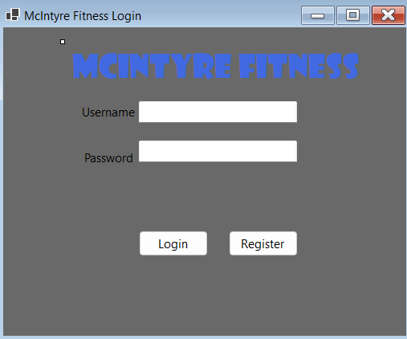

Register
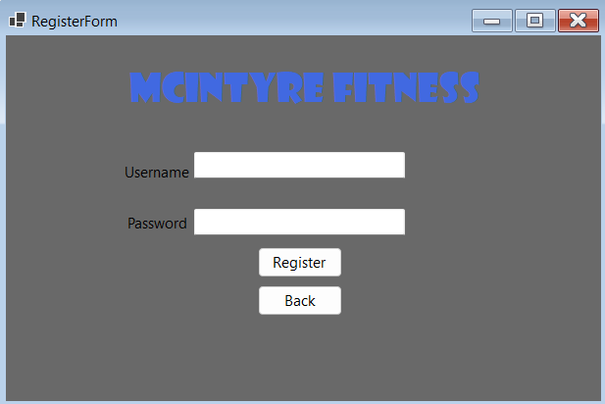
Dashboard
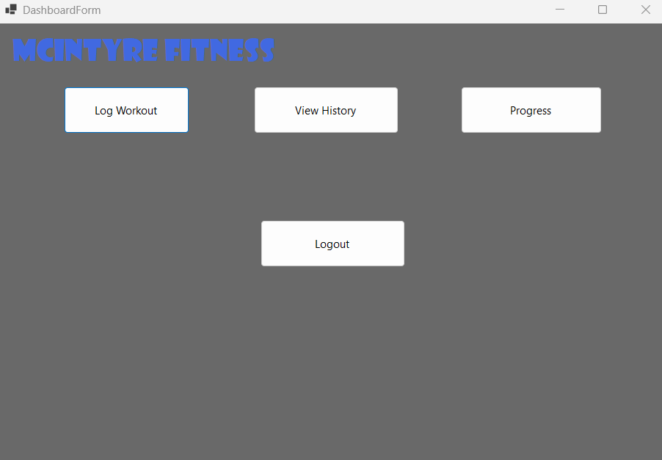

Progress
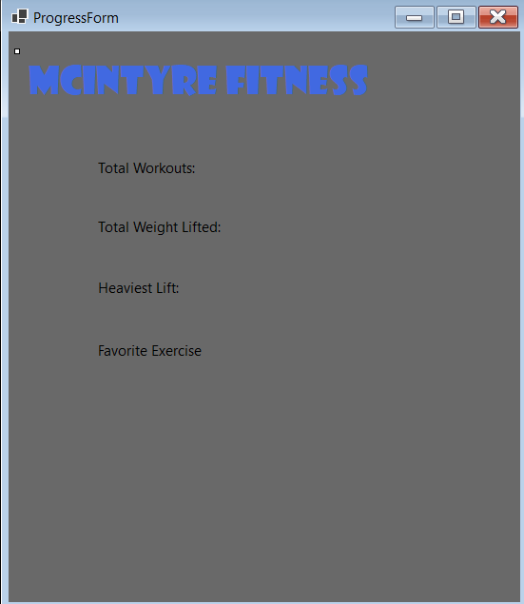
Workout Edit
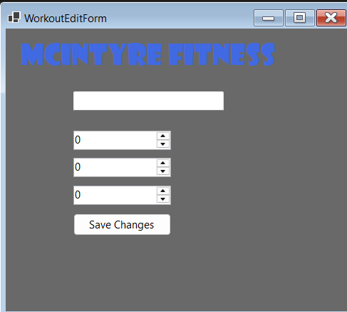

Create Workout
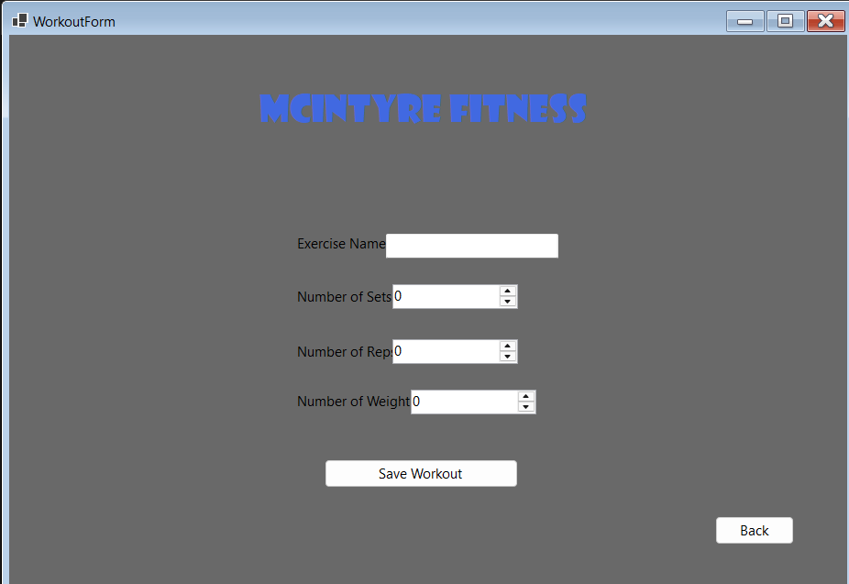

Workout History
